

Click to Begin



Back

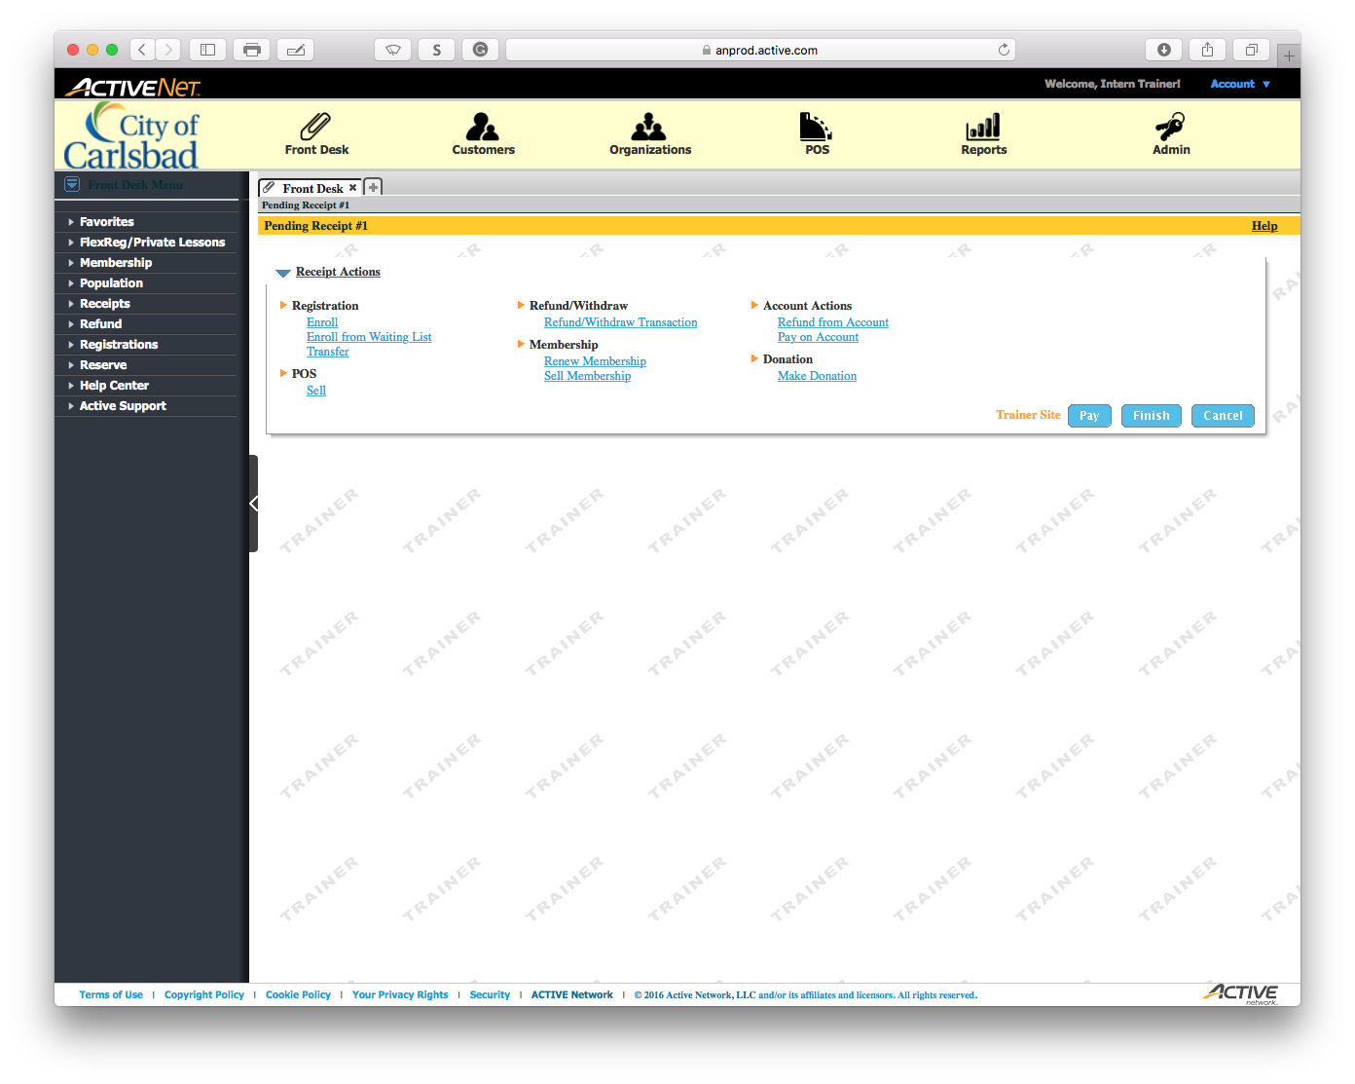

*Open the* ***Customers*** *module*

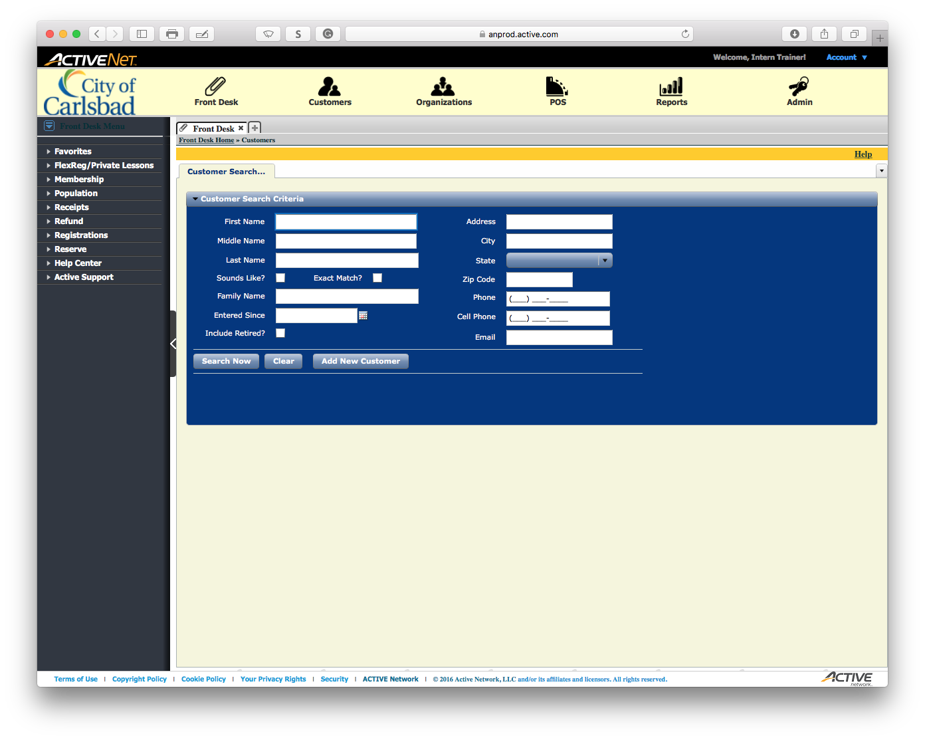

*Select the* ***First Name*** *field*

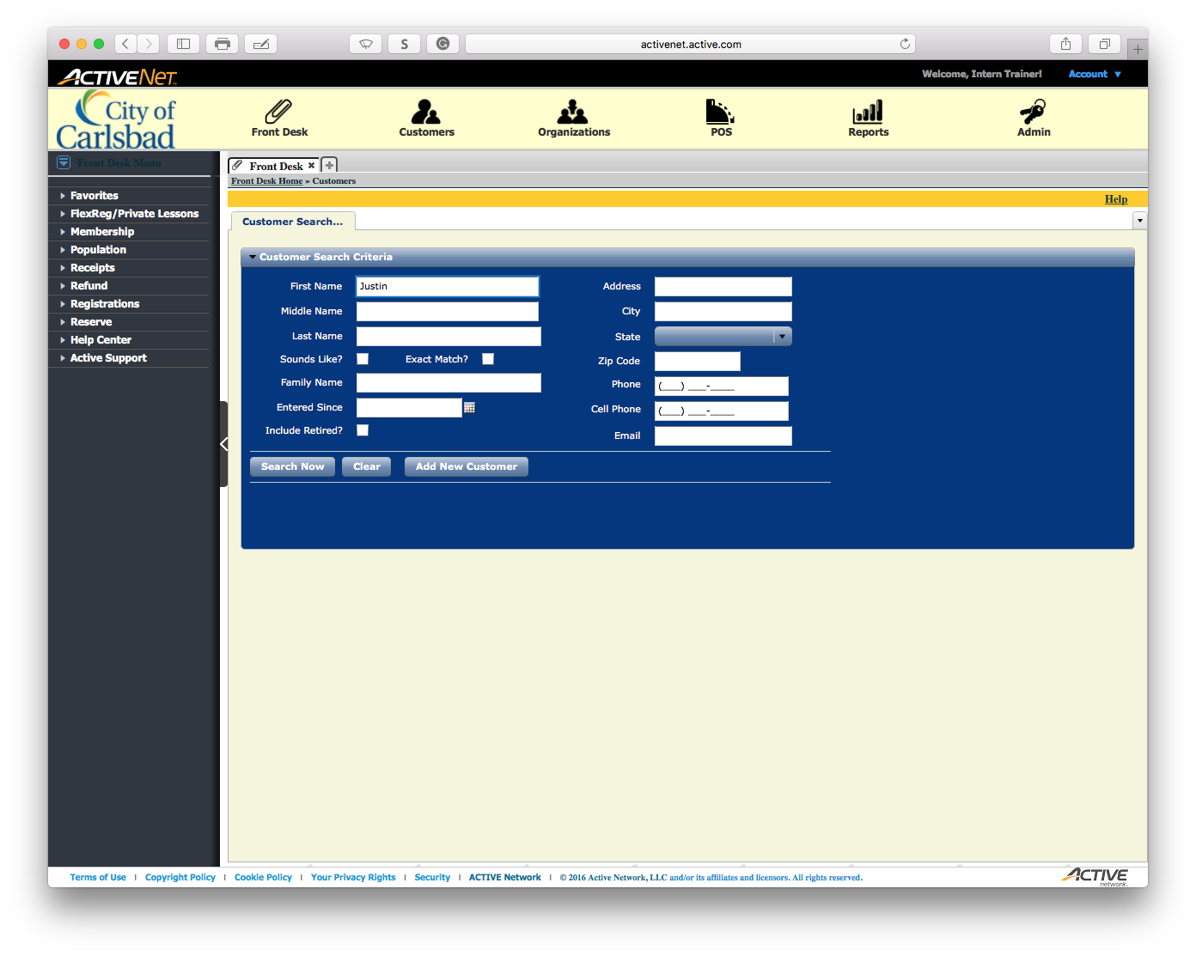

*Select the* ***Last Name*** *field*

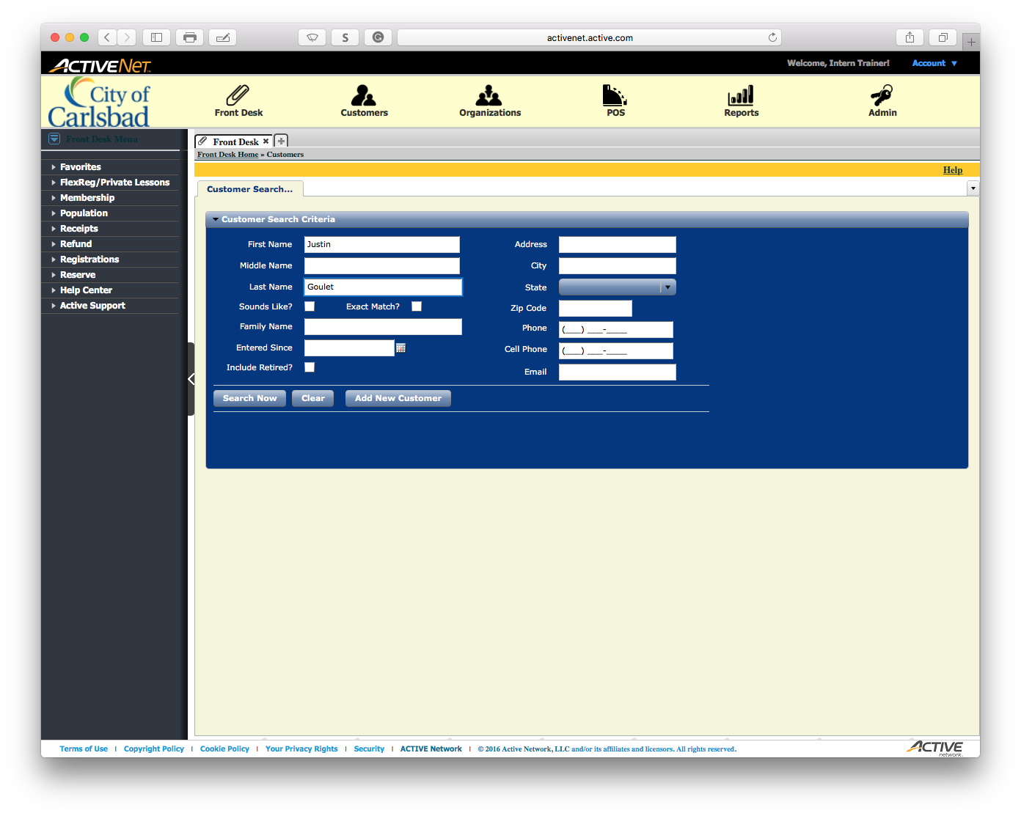

*Select the* ***Search Now*** *button*

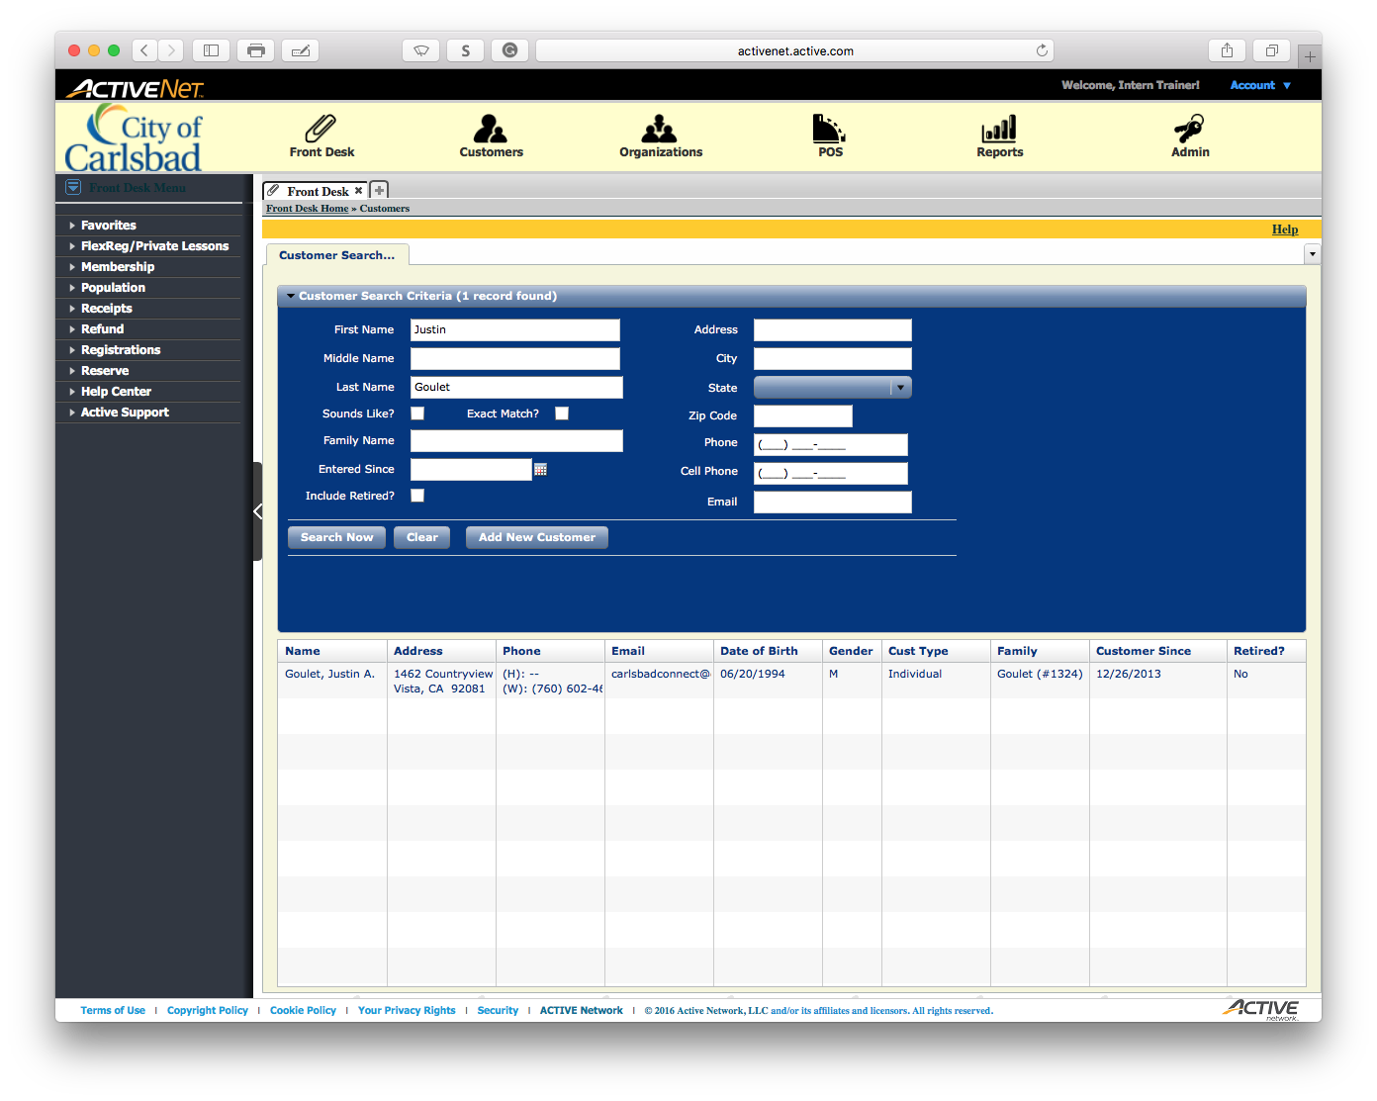

*Select the Customer from the list*

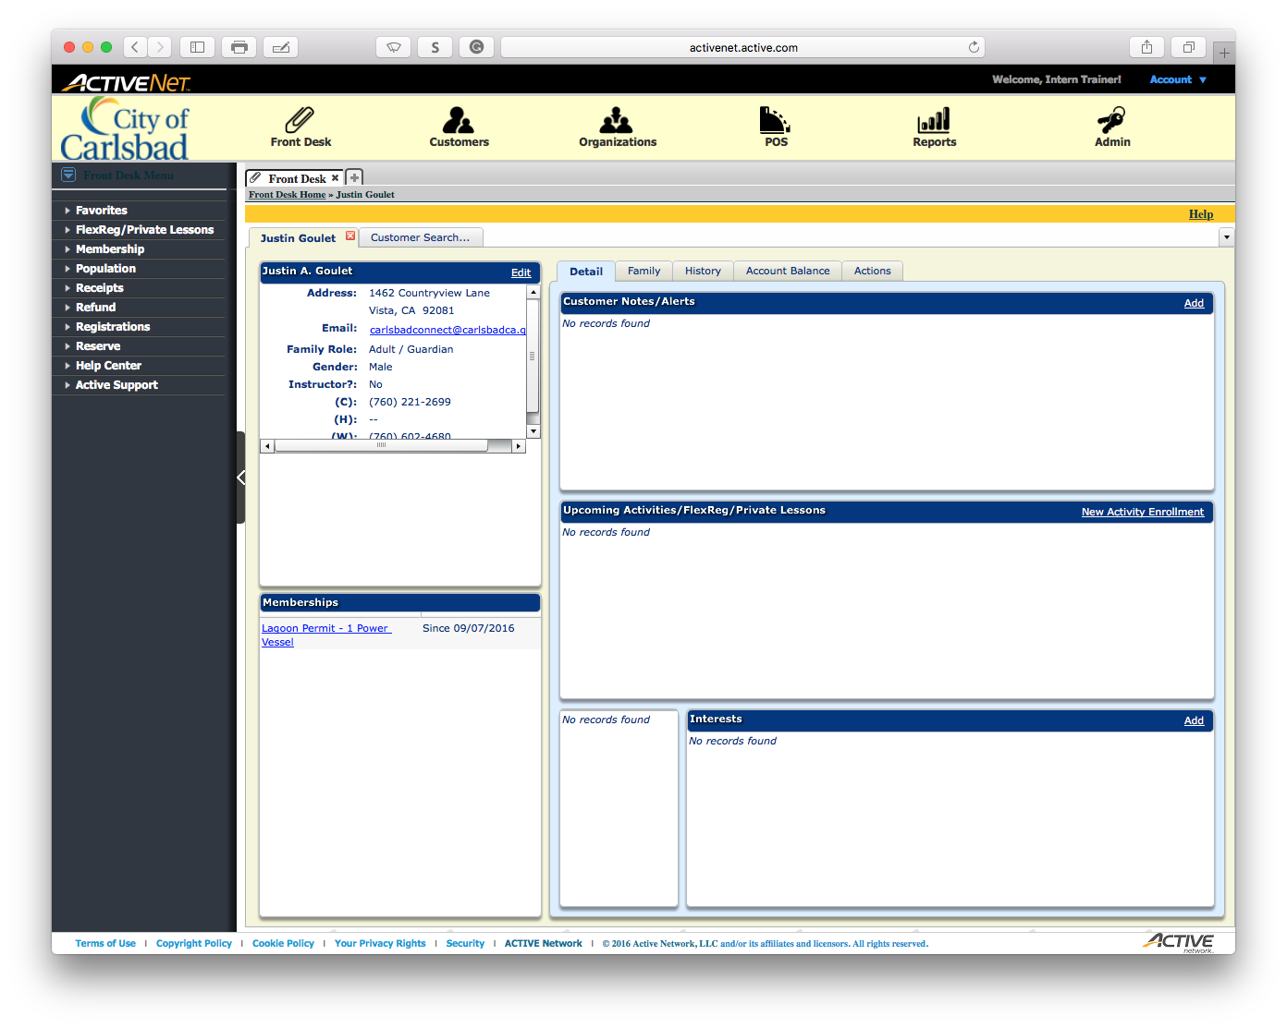

*Edit the Customer’s Information*

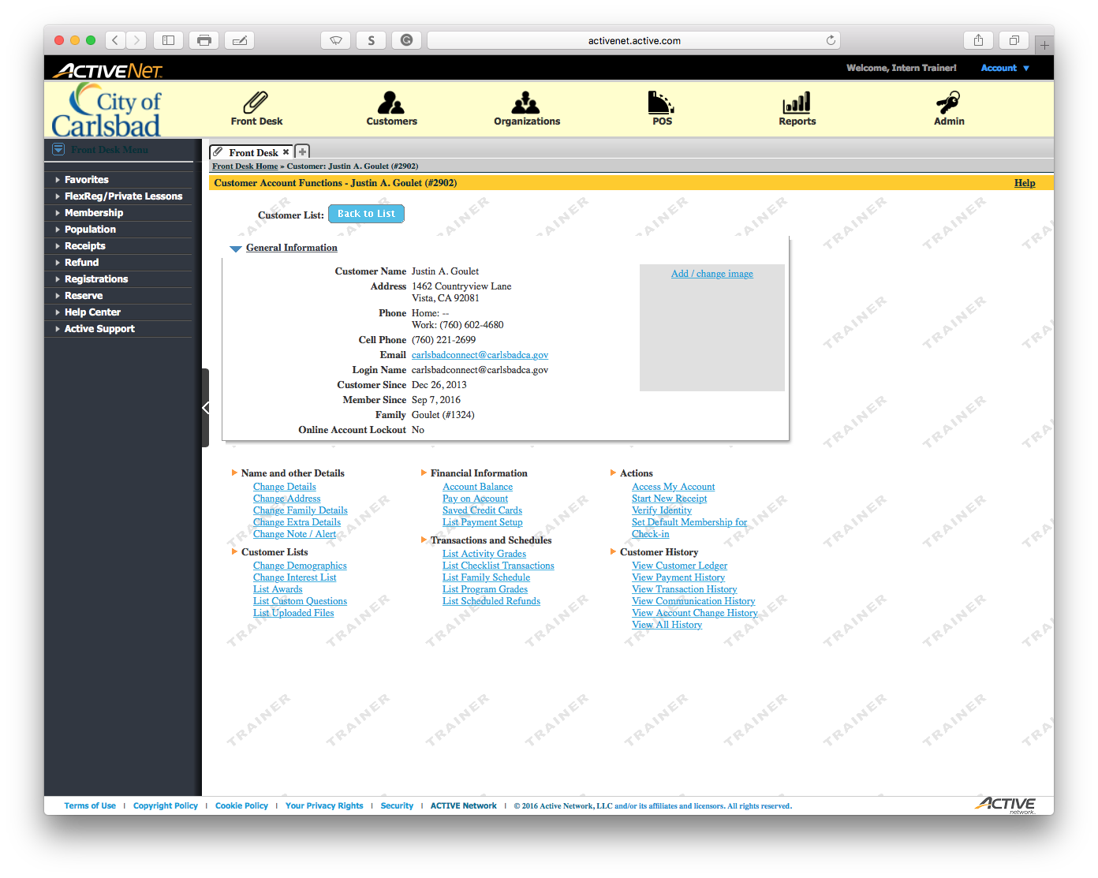

*Change the* ***Details*** *of the client*

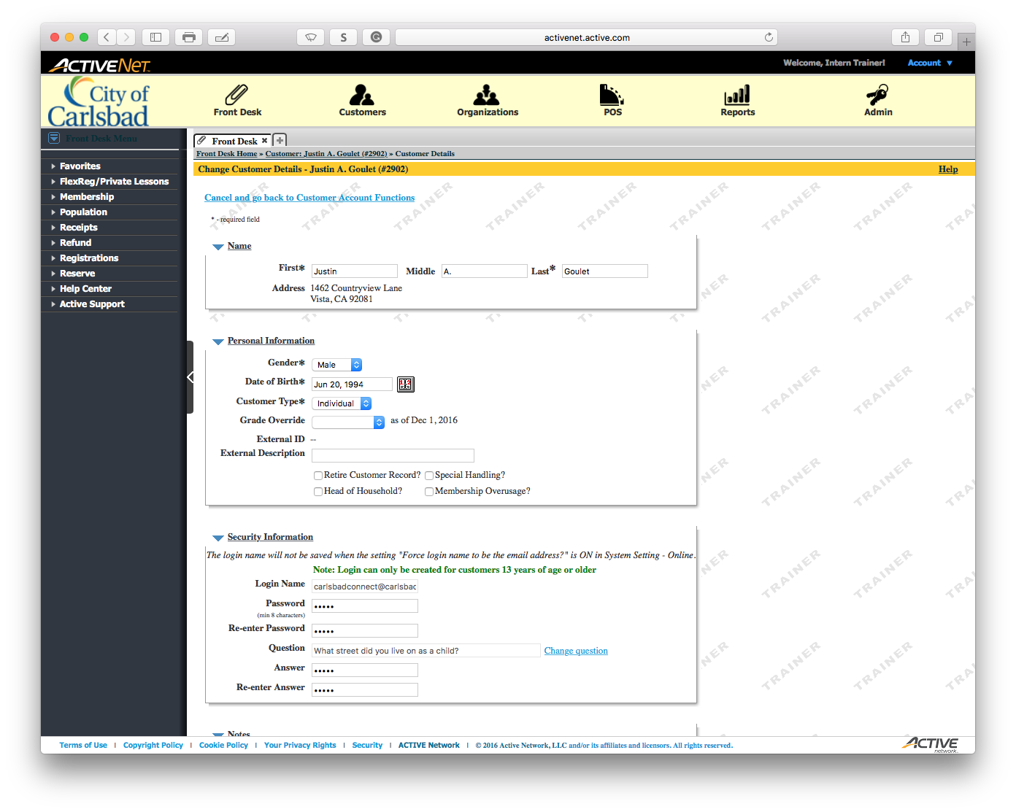

*Change the client’s birthday*

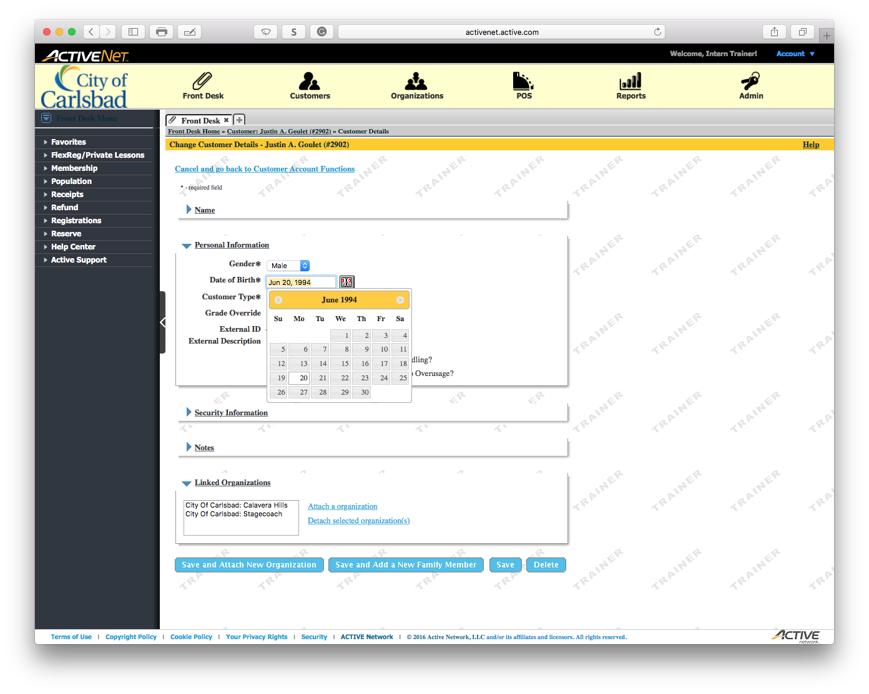

*Change the Birthday to June 1, 1994*

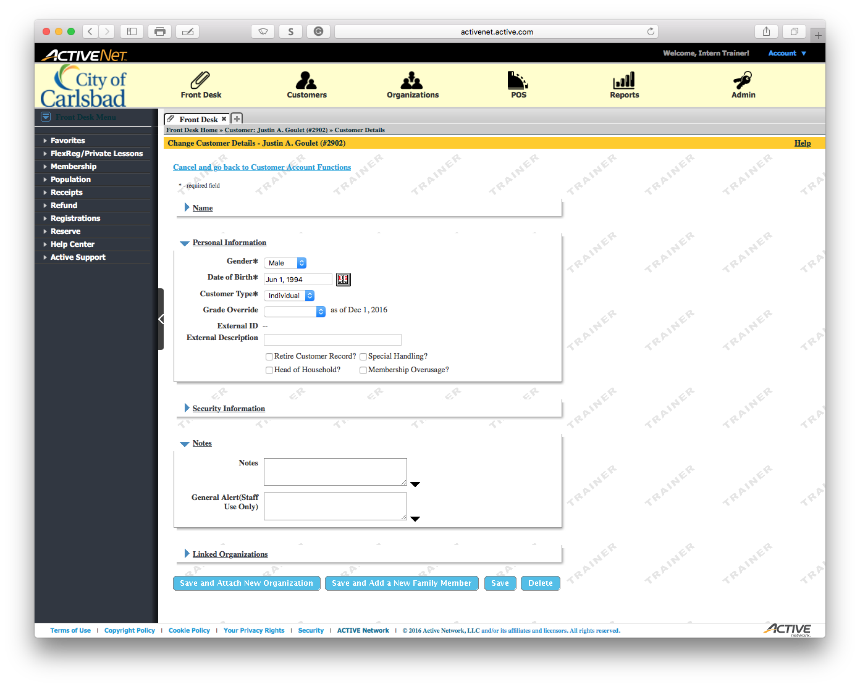

*Click to add a* ***Note*** *for the birthday change*

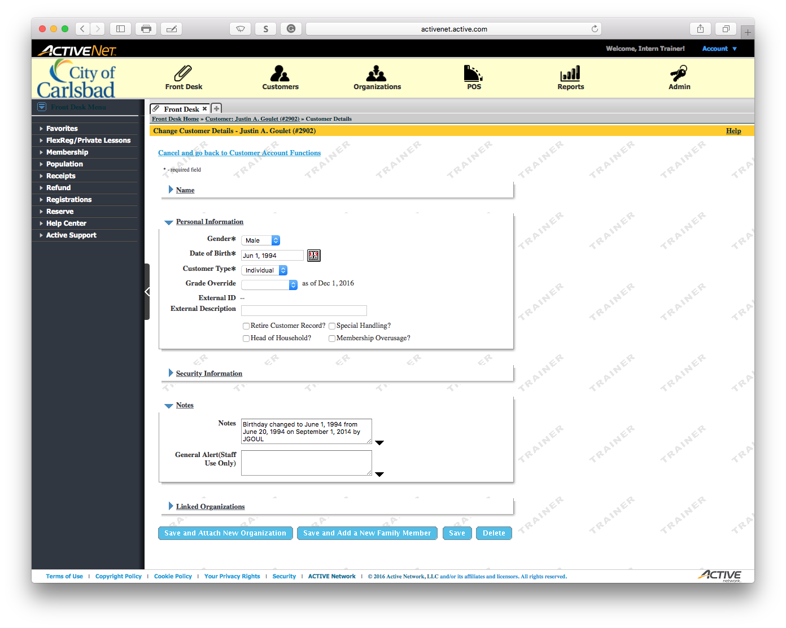

*Click to Save your Changes*

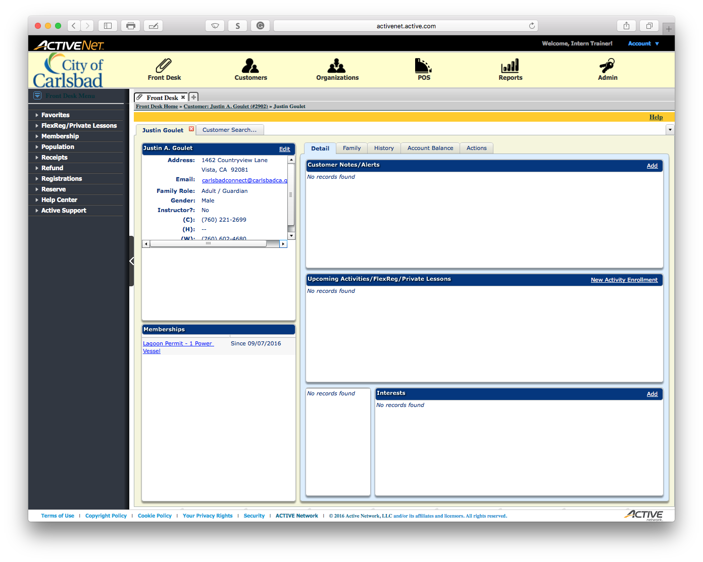

*Open the* ***Front Desk*** *module*



Start Over